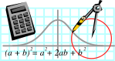  Rossmoyne SHS  Mathematics  Department | MATHEMATICS SPECIALIST 3A | Semester 1 2011  EXAMINATION

NAME:
TEACHER (circle) : Mr White Ms Rigelsford
Ms Belonogoff Ms Robinson Mr Jones

Section Two:
Calculator-assumed

Time allowed for this section
Reading time before commencing work: 10 minutes
Working time for this section: 100 minutes

Materials required/recommended for this section

To be provided by the supervisor
This Question/Answer Booklet
Formula Sheet (retained from Section One)

To be provided by the candidate
Standard items: pens, pencils, pencil sharpener, eraser, correction fluid, ruler, highlighters

Special items: drawing instruments, templates, notes on two unfolded sheets of A4 paper, and up to three calculators satisfying the conditions set by the Curriculum Council for this examination

Important note to candidates
No other items may be taken into the examination room. It is your responsibility to ensure that you do not have any unauthorised notes or other items of a non-personal nature in the examination room. If you have any unauthorised material with you, hand it to the supervisor before reading any further.
Structure of this paper

Section | Number of questions available | Number of questions to be answered | Suggested working time  (minutes) | Marks  available
Section One:  Calculator-free | 7 | 7 | 50 | 40
Section Two:  Calculator-assumed | 11 | 11 | 100 | 80
 |  |  |  | 120

Instructions to candidates

- The rules for the conduct of Western Australian external examinations are detailed in the Year 12 Information Handbook 2011. Sitting this examination implies that you agree to abide by these rules.

2. Answer the questions according to the following instructions.

Section Two: Write answers in this Question/Answer Booklet. All questions should be answered.
Show all your working clearly. Your working should be in sufficient detail to allow your answers to be checked readily and for marks to be awarded for reasoning. Incorrect answers given without supporting reasoning cannot be allocated any marks. For any question or part question worth more than two marks, valid working or justification is required to receive full marks. If you repeat an answer to any question, ensure that you cancel the answer you do not wish to have marked.
It is recommended that you do not use pencil except in diagrams.

3. You must be careful to confine your responses to the specific questions asked and to follow any instructions that are specific to a particular question.

- Spare pages are included at the end of this booklet. They can be used for planning your responses and/or as additional space if required to continue an answer.
  - Planning: If you use the spare pages for planning, indicate this clearly at the top of the page.
  - Continuing an answer: If you need to use the space to continue an answer, indicate in the original answer space where the answer is continued, i.e. give the page number. Fill in the number of the question(s) that you are continuing to answer at the top of the page.

QUESTION | MARKS AVAILABLE | STUDENT MARK
8 | 7
9 | 4
10 | 10
11 | 12
12 | 6
13 | 10
14 | 6
15 | 6
16 | 7
17 | 6
18 | 6
TOTAL | 80

Question 8
[ 7 marks]
Robert is asleep in his chair and unbeknown to him Tom, Dylan and Michael have each tied ropes around him and begin to pull with the forces and directions shown.  In which direction and with what force does the sleeping Robert move? Give the direction as a bearing. (answer to 1 decimal place) | 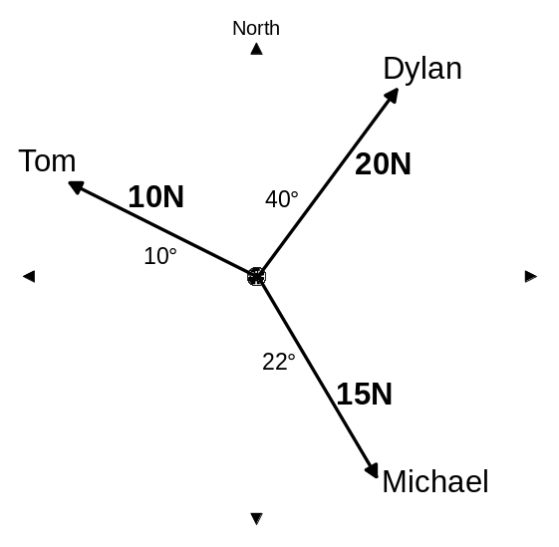

Question 9
[ 2 & 2 = 4 marks]
The graph below represents the function 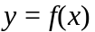.

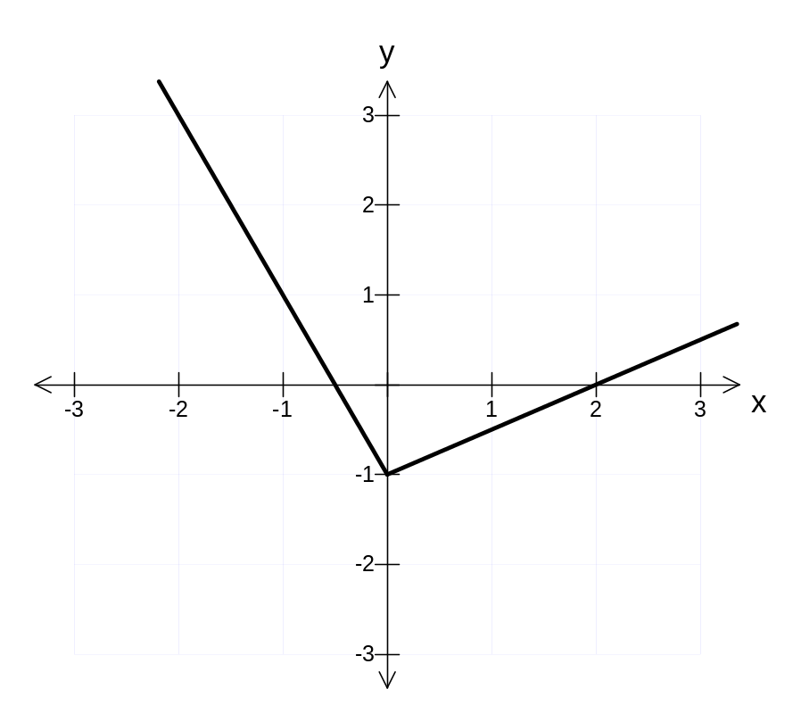

Using the axes shown below, sketch the graphs of:

a) 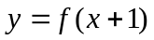 | b) 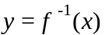
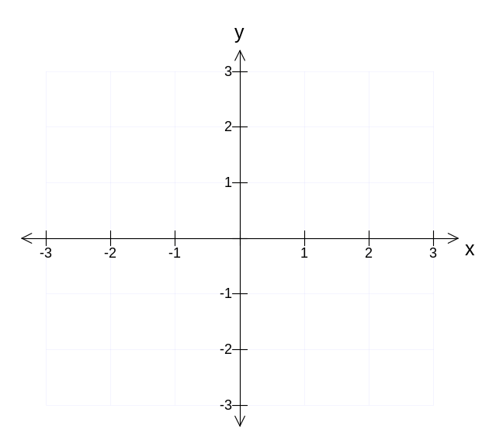
 | ]

Question 10
[ 1 , 2 , 3 & 4 = 10 marks]

At 11am a ship is known to have the coordinates (3,-7) km and is moving with constant velocity 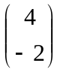 km/hr. Its home harbour has coordinates (0,0) km.

a) Write down an expression for the ship’s position vector from the harbour at time t hours after 11am..

b) Determine the ship’s distance from the harbour at 2pm (t=3 hours).
(1 decimal place)

At 11am a tug boat leaves the harbour with a velocity 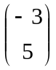 km/hr.
c) Determine the distance between the tug boat and the ship at 2pm.
(1 decimal place)

d) At what time, to the nearest minute, will both the ship and the tug boat be equidistant from the harbour?

Question 11
[ 2, 3, 3 & 4= 12 marks]

The functions , & are defined as follows.

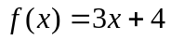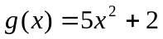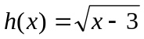

a) Determine the natural domain and range of .

b) Which of the following composite functions exist over the natural domain of ? Those that do not exist, give a reason why.

i) 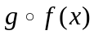

ii) 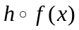

c) For those composite functions in (b) that do exist, state the rule and the range for the natural domain of . (Do not simplify)

d) The function is defined as 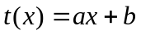 with 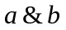 being constants.
If 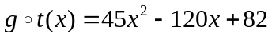, determine the values of (exact).

Question 12
[ 2 & 4= 6marks]

a) Point A has position vector 3i – 2j. Points B and C are such that the position vector of B relative to C is 5i + 8j and the position vector of C relative to A is 9i – j. Determine the position vector of B.

b) To a person walking due North at 5 km/h the wind seems to come from the West (heading due East). To a second person walking due East at 12 km/h the wind appears to come from the South-East (heading North 45º West). Determine the true magnitude and direction of the wind. (1 decimal place)

Question 13
[ 2, 2, 1, 2, 1 & 2 = 10 marks]

The magnitude (M) of earthquakes is measured on the Richter scale and is given by 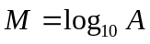, where A is the amplitude of ground movements.

a) Restate the model in the format, A= .

b) Determine the amplitude of ground movements for an earthquake of magnitude (one decimal place)
i) 6.1.

ii) 4.7

c) How many times more intense (in terms of amplitude) is a quake of magnitude 6.1 compared with one of magnitude 4.7?

The energy, E, (joules) released by an earthquake of magnitude M is given by
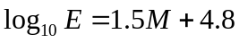.

d) Restate the model in the format E=.

e) Determine the energy released by an earthquake of magnitude 6.1.

f) If a nuclear bomb released 6x10¹⁵ joules of energy on detonation, what would be the magnitude of an earthquake which would release the same energy? (one decimal place)

Question 14
[ 6 marks]
A garden bed is the shape of a sector of a circle with radius 7m as shown. The perimeter of the garden bed is to be 25 metres. The top segment (shaded in the diagram) is to be filled with a special soil conditioner as native trees are to be planted in that area. The rest of the garden bed will have flowers planted in it and does not need any soil conditioner. The instructions on the bags of soil conditioner suggest a layer 5cm deep should be added to the top of the existing soil and then mixed in. Each soil conditioner bag holds 30 litres. How many bags will the gardener need to purchase? Justify your answer.  (Note: 1 kilolitre = 1 m³) | 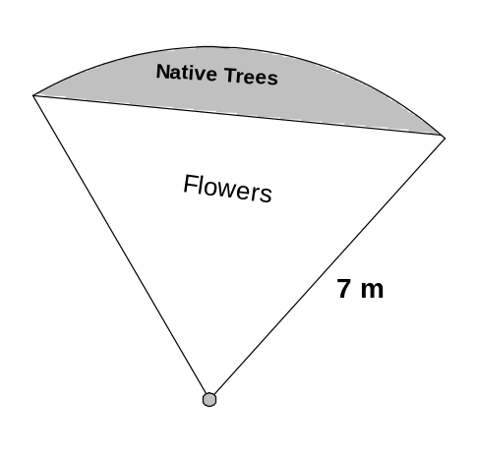

Question 15
[ 6 marks]

Two circles of radii 10 cm and 8 cm have their centres 14 cm apart. Determine the perimeter of the region common to both circles, giving your answer in centimetres and correct to one decimal place.
Question 16
[ 5 & 2= 7 marks]
A plane needs to travel directly from City A (0,0) km to City B (-600,800) km. The plane travels at a speed of 75 km/hr relative to the wind. The wind’s velocity is -50i + 20j km/hr. The j vector faces due North.

a) Determine the bearing of the plane’s velocity relative to the wind.

b) Determine the time taken, to the nearest minute, for the plane to travel from City A to City B.

Question 17
[ 3 & 3 = 6 marks]

Lena is working at a mine site in the middle of the desert. To make her way back to Perth, Lena must first ride a motorcycle 25 km on a bearing of 050º to the nearest airport. Lena then flies directly to Perth on a bearing of 170º.
It is known that the bearing of Perth from the mine site is 158º.

a) Determine the distance Lena travels by plane.

b) Determine the distance between the mine site and Perth.

Question 18
[ 6 marks]

Let 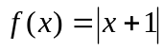 with the domain all Real numbers.
If 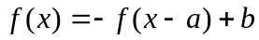 is only true for 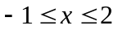 with being constants, determine the values of .

{Hint: First consider a sketch of .}

End of Exam !!
Working out space
Please indicate under question if you use this space.
Working out space
Please indicate under question if you use this space.
Working out space
Please indicate under question if you use this space.

End of Booklet.

